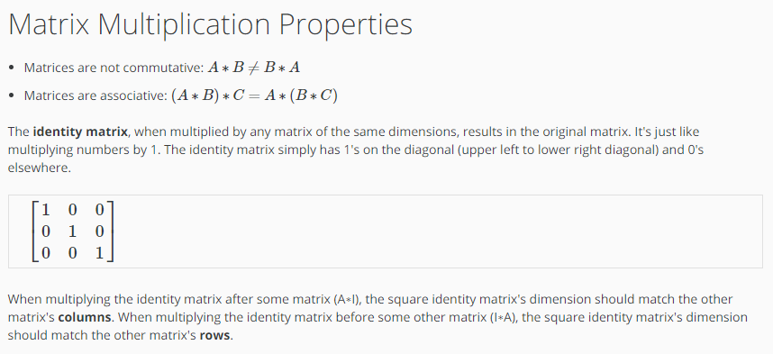
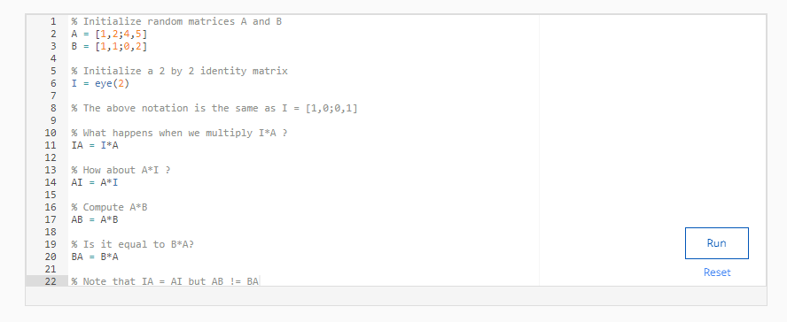

CODE:
% Initialize random matrices A and B
A = [1,2;4,5]
B = [1,1;0,2]

% Initialize a 2 by 2 identity matrix
I = eye(2)

% The above notation is the same as I = [1,0;0,1]

% What happens when we multiply I*A ?
IA = I*A

% How about A*I ?
AI = A*I

% Compute A*B
AB = A*B

% Is it equal to B*A?
BA = B*A

% Note that IA = AI but AB != BA

OUTPUT:
